**Assignment 2: 15 Docker command**

**1). docker – version**

This command will show the installed version of Docker and is the first step to checking whether Docker is installed or not.

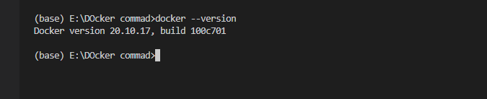

**2). docker pull docker/<image name>**

This will pull the image, if not found locally it will search in the Docker hub and download it locally.

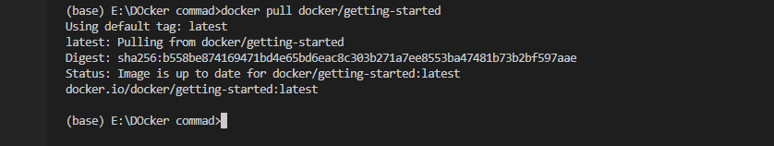

**3). docker images**

Shows all the images running currently.

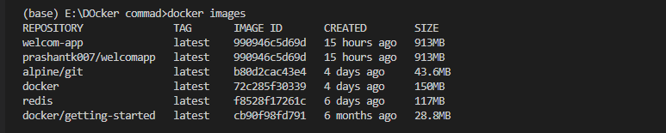

**4). docker run -d -p 80:80 docker/<image name>**

Run the image

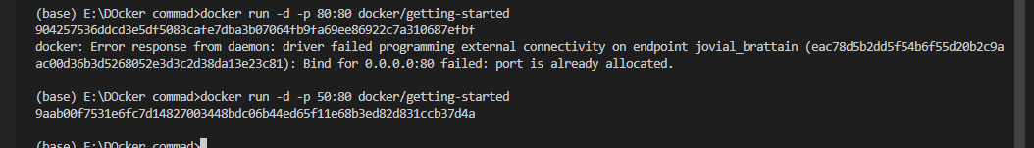

**5).docker ps**

Shows all the running container.

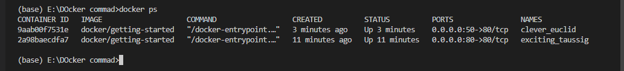

**6).docker run -d -P docker/getting-started**

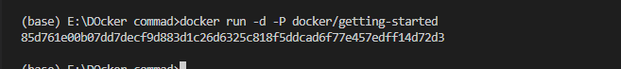

**7)docker build -t <image name>**

This will build a Docker image.

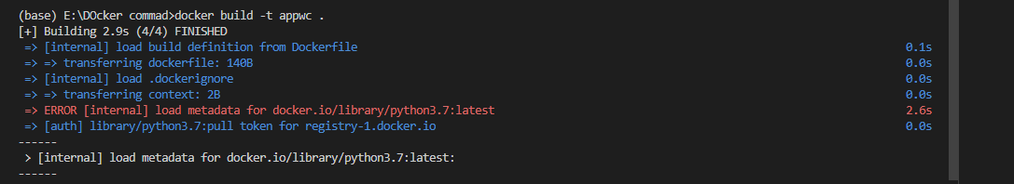

**8)docker stop<container id>**

Gracefully stop the specific container.

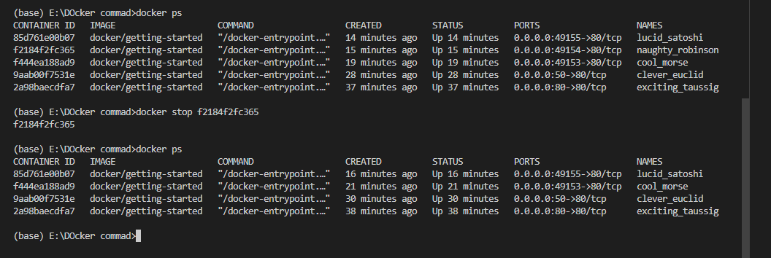

**9)docker kill<container id>**

Force shutdown of a specific Container.

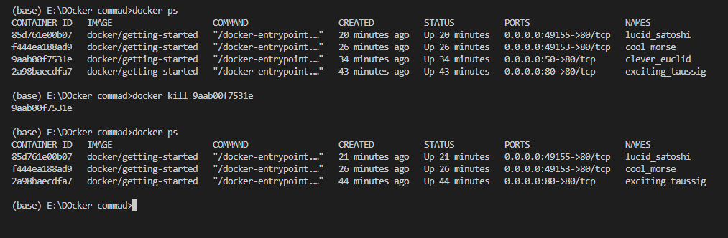

**10)docker rmi<image name>**

Remove that specific image from this Machine.

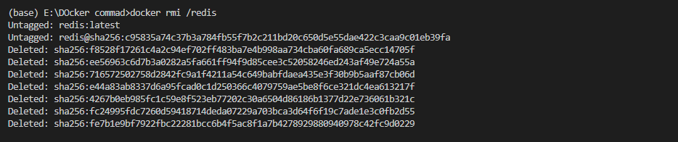

**11)docker volume prune**

Remove all unused local volumes.

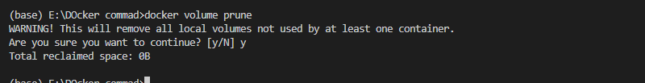

**12)docker volume create <name>**

Will create volume

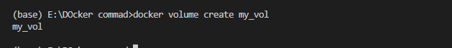

**13)docker search <image name>**

Can search images by their name.

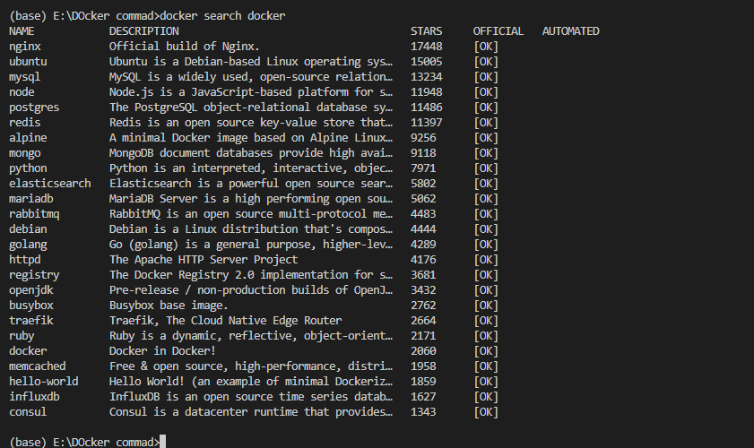

**14)docker start <container id>**

Start stopped container.

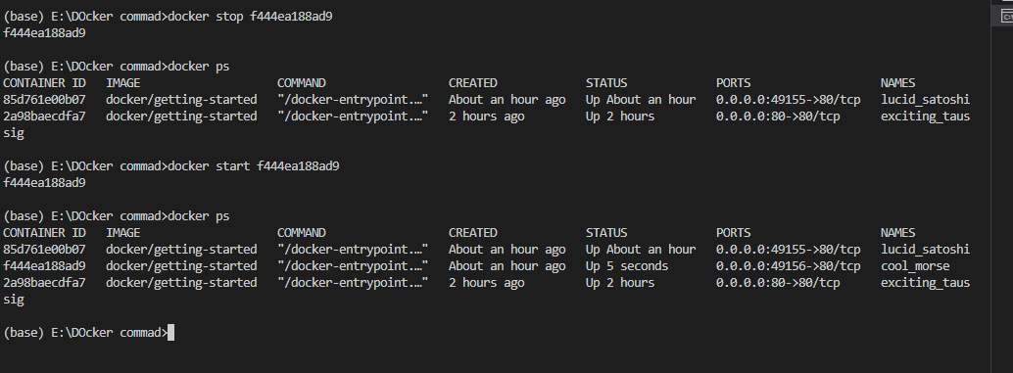

**15).wsl –shutdown**

Will shutdown the docker

